**Section 25 done: 13/13 Bonus: A Brief Introduction to Redux Saga**  
**Introduction**  
* **Redux Saga - an alternative to redux-thunk**.  
* When working with Redux, we also have to deal with the “problem” of handling Asynchronous ACTIONs, like reaching out to a server.  
* We dealt with this “problem” by using redux-thunk.  
* **redux-thunk** is a package which allows us to create ACTION CREATORs where we run the Asynchronous code and where we then dispatch() other ACTIONs once we’re done.  
* And there’s nothing wrong with this approach, that’s really important.  
* In this module I’ll present an alternative which is not necessarily better or worse, it’s just an alternative, which you might like more or not.  
* **Redux Saga** is a package which follows a different approach of working with Asynchronous code.  
* And it doesn’t mix it with the act of dispatching ACTIONs.  
* Let’s try it in our Burger Builder project.  
**Installing Redux Saga**  
* We handle all these Asynchronous tasks or actually any side-effects - even Synchronous ones - so things that are not directly related to changing our Redux STORE, we handle all these things in ACTION CREATORs.  
* In auth.js we have some Synchronous ones here, but then we also have things like accessing localStorage and LOGOUT, which is a Synchronous ACTION but which you could argue - and again that’s not necessarily the best practice - but you could argue that this is not really related to the act of dispatching an ACTION, so maybe you don’t want to have it in this file. And we also have Asynchronous ACTIONs, like checkAuthTimeout where we have a timeout we set and where we then dispatch() LOGOUT after a certain expiration time. And we reach out to the web, we make POST Requests and obviously we have to wait for these to finish.  
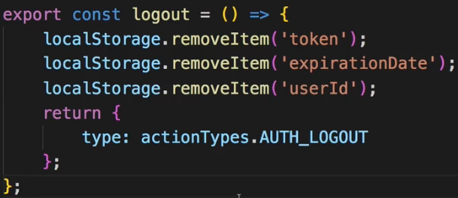 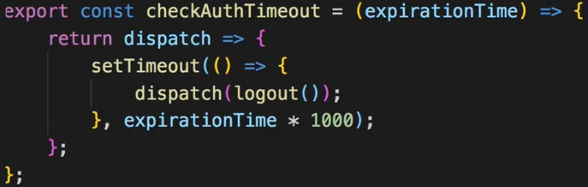  
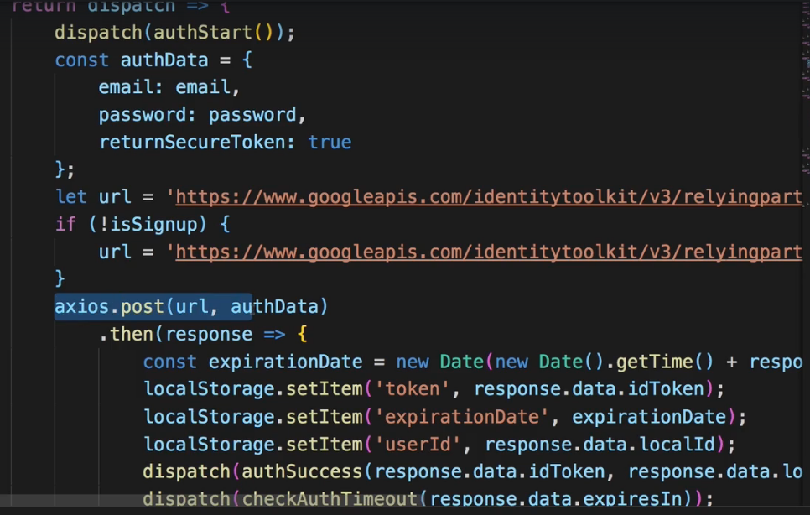  
* **So all these are things which we have in the ACTION CREATORs and as I said multiple times that’s not necessarily bad, but you could make the argument that you want ACTION CREATORs, or the whole idea of dispatching ACTIONs, to be very clean, that you don’t want to have any other code in there which is not really related to dispatching an ACTION**.  
* **And this is where Redux Saga comes in**.  
* First of all let’s install it.  
**npm install --save redux-saga**  
* This will, as always, download it, place an entry in the package.json file and then give us access to it in this project.  
* Now we can start using Redux Saga.  
**Creating our First Saga**  
* With Redux Saga you creates to called Sagas which are essentially kind of functions which you run upon certain ACTIONs and which handle all your side-effect logic. And a side-effect is simply something like accessing Local Storage, reach out to a server, maybe changing the route, or executing timeout. These are all side-effects because they don’t directly manipulate your Redux STORE. They might do something which leads to a different state which in the end is stored in your Redux STORE, but they’re not directly consumed by the REDUCER.  
* Let’s create a `sagas` subfolder in the `store` folder.  
* There I’ll create different files for different types of sagas.  
* Let’s create auth.js.  
* Saga in its core is kind of like a function and I’m saying kind of because there’s a little twist to it.  
* Now on this function I can accept an argument which I will in the end get automatically, I’ll of course show you how to wire up such sagas. The argument would be the `action` which was dispatched because sagas are related to ACTIONs.  
=> I said kind of a function: let’s add a **\*** after the function keyword and this * here is important, it’s not part of the function name, it’s actually turning this function into a so called **GENERATOR**.  
=> Generators are Next-Gen JavaScript features which are functions which can be executed incrementally - so you can kind of call them and they don’t run from start to end immediatelly, but you can pause during function execution, for example to wait for an Asynchronous code to finish. And that is exactly what Redux Saga takes advantage of. And if you just have Synchronous code, you can just execute it from start to end immediatelly.  
* ACTION CREATOR:  
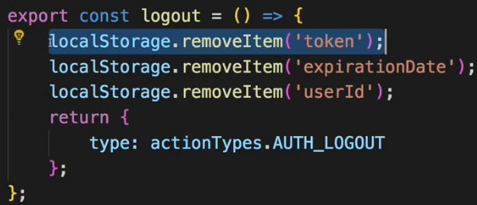  
=> There at the end we return this ACTION object which essentially would lead to this being dispatched. So we want to do the same in a saga.  
* SAGA:  
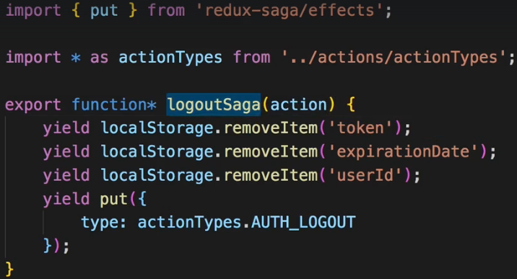  
=> In saga we do this with a special function we get from the package we just installed.  
=> `**put**` in the end will just dispatch() an ACTION.  
=> In a GENERATOR, we should prefix/prepend each step we execute with the `**yield**` keyword. This simply means that this step should be executed and that it’ll wait for it to finish so if it were an Asynchronous ACTION, it wouldn’t continue until the step is done.  
* Now this is a Redux Saga and it looks like a more complicated way of creating an ACTION CREATOR right? Well the idea is of having your separate area in the application where you deal with that. We have our `logout` generator and we only kind of need to hook it up to our STORE to be able to use it.  
**Hooking the Saga Up (to the Store and Actions)**  
* To hook it up to the STORE we need to go to the place where we create our STORE, index.js.   
* There I want to register my sagas.  
  
  
  
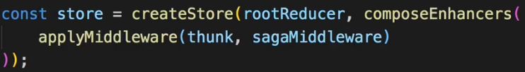  
  
* In Redux Devtools we see that we execute AUTH_LOGOUT twice because:  
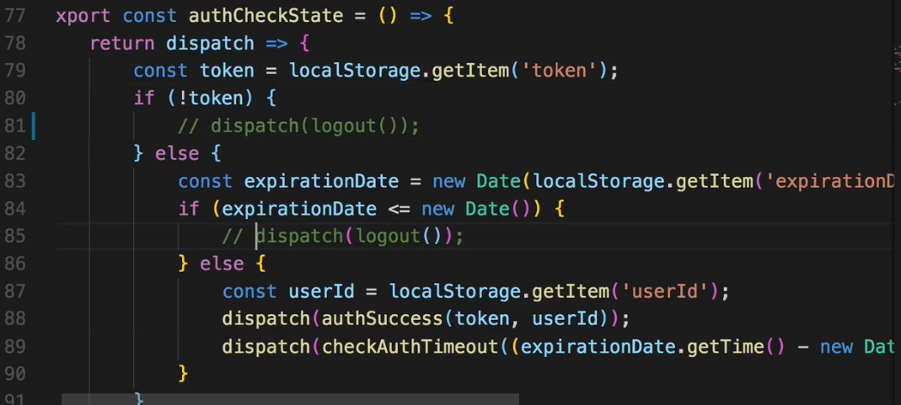  
=> Let’s comment out all logout dispatches here.  
* If we try it now, we still see that 1x AUTH_LOGOUT was dispatched - and that is coming from our saga.  
* Now always calling this saga doesn’t look too useful - right now right at the start where we build the application, where we start it, we run our logoutSaga which despite the strange GENERATOR stuff going on, simply does 1 thing - it removes all these items from Local Storage and dispatched the AUTH_LOGOUT ACTION. Obviously we don’t want to run this at application startup, instead, we do want to run this code in the place where we previously ran our `logout` ACTION CREATOR, so the goal has to be that we actually dispatch() an ACTION to which we can listen with Redux Saga so that our saga generator can run once the ACTION is recognized.  
**Moving Logic from the Action Creator to a Saga**  
* Let’s comment out the Local Storage code in the auth.js ACTION CREATOR:  
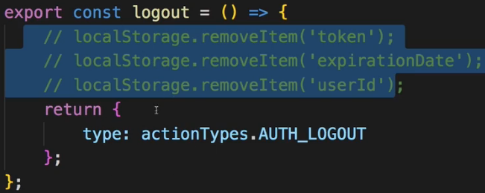  
=> I want to just dispatch() and ACTION, I want to create an ACTION, nothing else, no side-effects anymore because I want to handle these with Redux Saga now.  
=> So let’s dispatch() something here and I’ll create a new ACTION TYPE for that. Let’s call it INITIATE because it’s kind of the step before we really log out.  
  
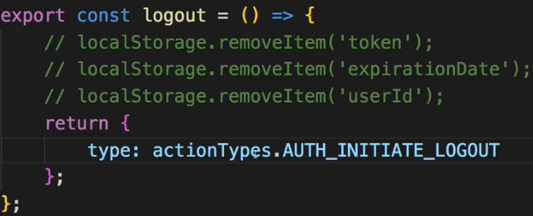  
=> So whenever I dispatch() `logout`, I’ll simply INITIATE_LOGOUT instead. Now the goal is to listen to this newly created ACTION CREATOR and execute out `logoutSaga` generator whenever we detect this INITIATE_LOGOUT call.  
=> For that let’s create index.js in `sagas` folder, you can also name it rootSaga or whatever.  
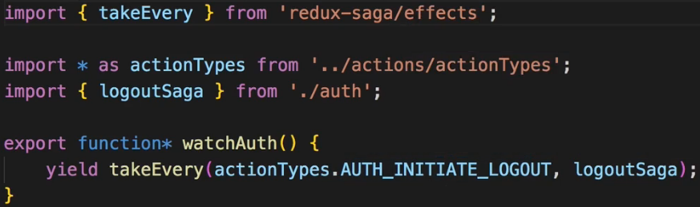  
=> This **takeEvery** will allow us to listen to certain ACTIONs and do something when they occur.  
=> What this’ll do is that whenever we execute this generator, we’ll basically set up a listener to AUTH_INITIATE_LOGOUT and then execute `logoutSaga` whenever that appears.  
* Now in the main index.js:  
  
  
* Now this works.  
* Let’s now replace all our side-effects in the ACTION CREATORs with saga generators instead.  
**Moving More Logic Into Sagas**  
* Now I used this approach where we just put({}) an object, we could even get rid of all ACTION CREATORs now that we use sagas, but we could also say that we want to use ACTION CREATORs to have a reliable way of creating our ACTIONs and therefore we should probably also use an ACTION CREATOR here in our saga, instead of hard-coding the ACTION object in here:  
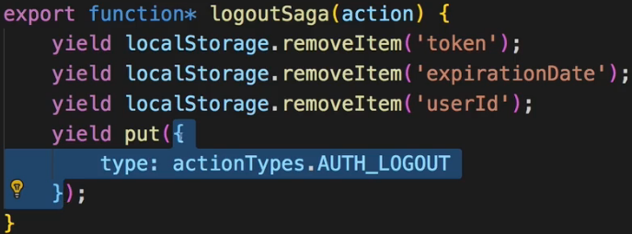  
=> So let’s create a new ACTION CREATOR in auth.js. You could also name it didLogout or whatever.  
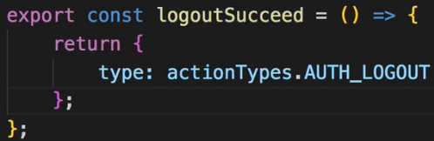 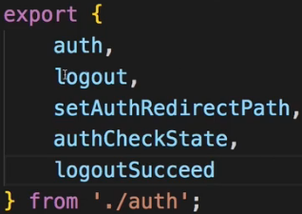  
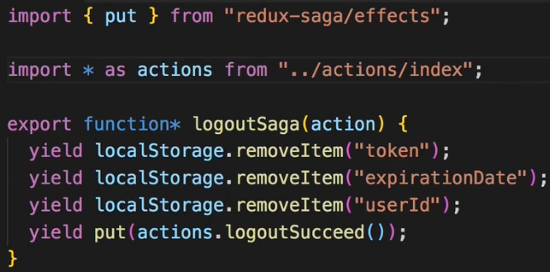  
* We simply execute an ACTION CREATOR in here.  
* So with that I have a consistent approach of using ACTION CREATORs.  
* Now checkAuthTimeout is also causing some side-effects here.  
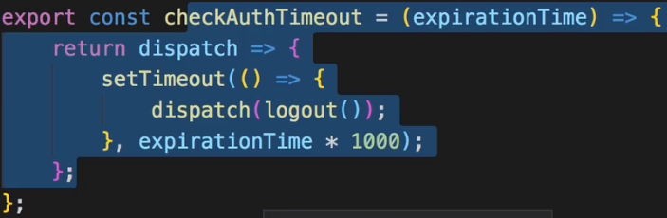  
=> This is something we definitely wanna do in our saga instead.  
* For that let’s import a HELPER FUNCTION: **delay**. It delays the execution of the next step.  
  
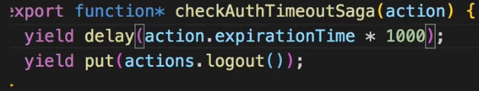  
  
* This put() will eventually lead to the logoutSaga being executed.  
* In the checkAuthTimeout ACTION CREATOR now I simply just want to dispatch() an ACTION which leads to this checkAuthTimeoutSaga generator being started.  
=> For that I’ll add a new ACTION TYPE.  
  
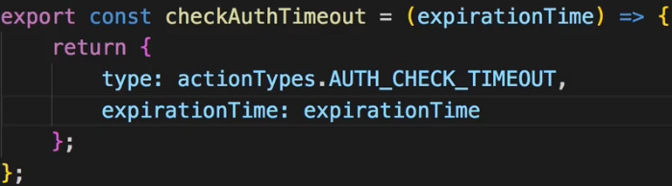  
* In index.js in `sagas`:  
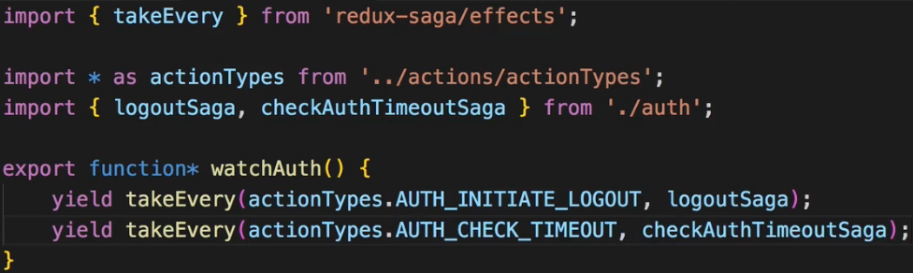  
**Handling Authentication with a Saga**  
* Let’s see what else we can put into a saga from our ACTION CREATOR file.

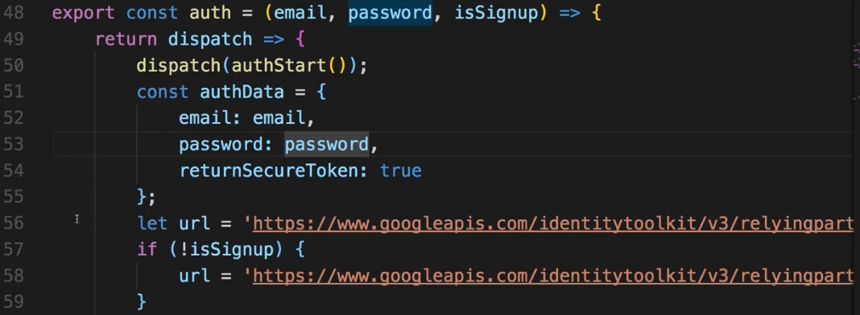  
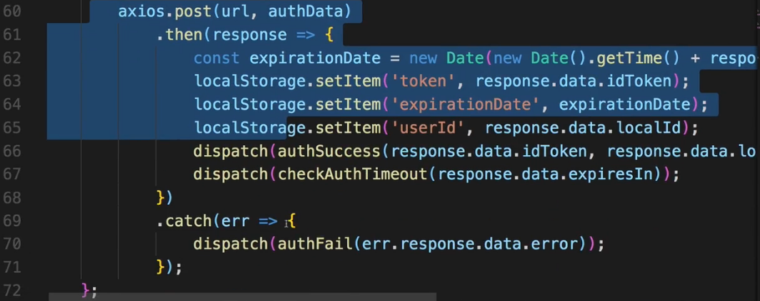  
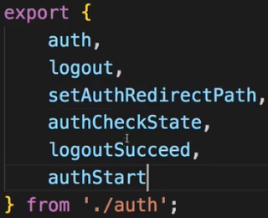  
* In auth.js `sagas`:  
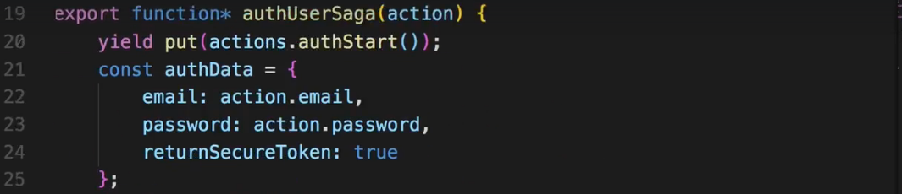  
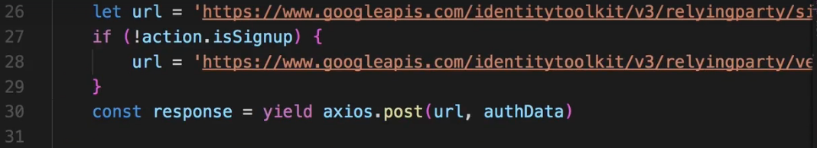  
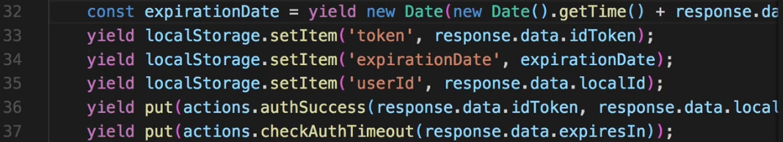  
* Now something important is done: I will actually change the way we use this PROMISE that POST returns us. Right now we get the `response` there and then we do something with the `response`.   
* Now with doing this, it will actually not return a PROMISE anymore but wait for this PROMISE to RESOLVE or REJECT and then store whatever we get back in this const. So I no longer need to chain .then() here. And of course it also means that all the code that depends on response, can now be executed kind of Synchronously, because execution will pause here until this PROMISE is RESOLVED or REJECTED.  
* We can add `yield` in front of localStorage to have a consisntent approach, though we don’t really have to do that, could also add it in front of new Date().  
* What about the error that was in .catch()? Well we can handle this in a very elegant way.  
=> We can use a default JavaScript construct to handle both a success and an error case - we can wrap this in a `**try**` block  
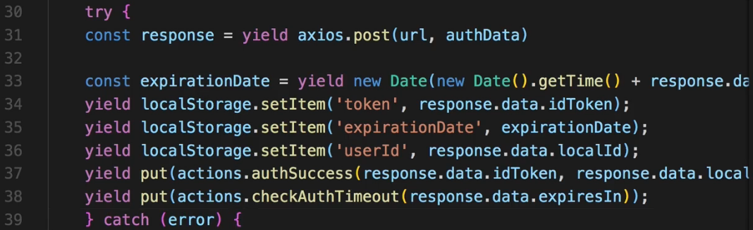  
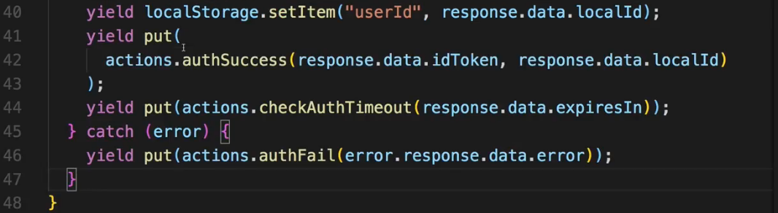  
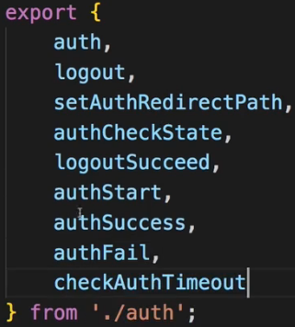  
* Now we have to make sure that the authUserSaga gets executed when we try to create or sign a user in.  
* So in auth.js `actions` file.  
* Let’s create a new ACTION TYPE.  
  
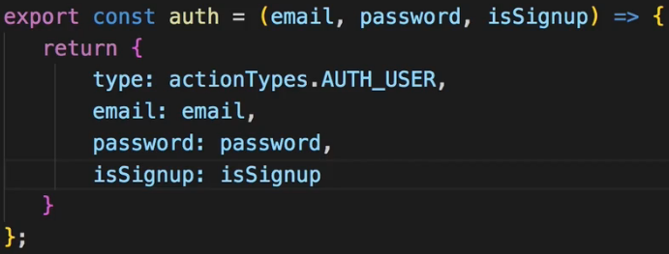  
* Very important: in our authUserSaga generator, we of course extract email, password and isSignup from the ACTION so we need to pass that information on when we create the ACTION.  
* Now in `sagas` index.js file:  
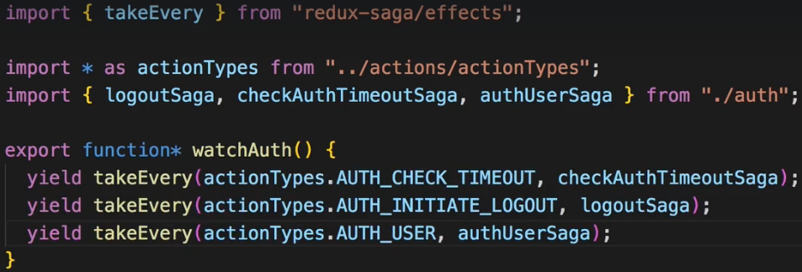  
**Handling Auto-Sign-In with a Saga**  
* Now we have a very lean ACTION CREATOR file auth.js. Now we only have ACTION CREATORs that return ACTIONs, they really do just that, they create ACTIONs.  
* There’s 1 more ACTION CREATOR in auth.js to change:  
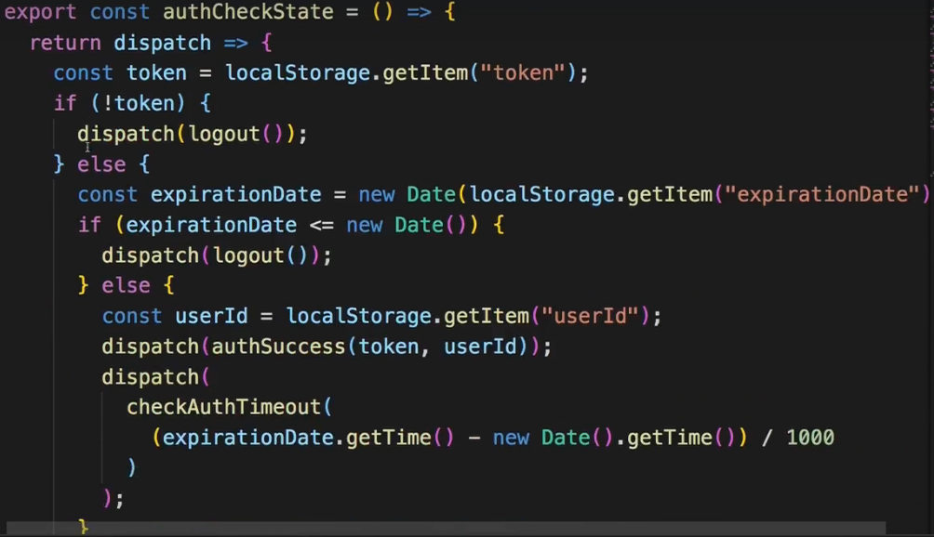  
=> These are all the changes I need to have a saga for it:  
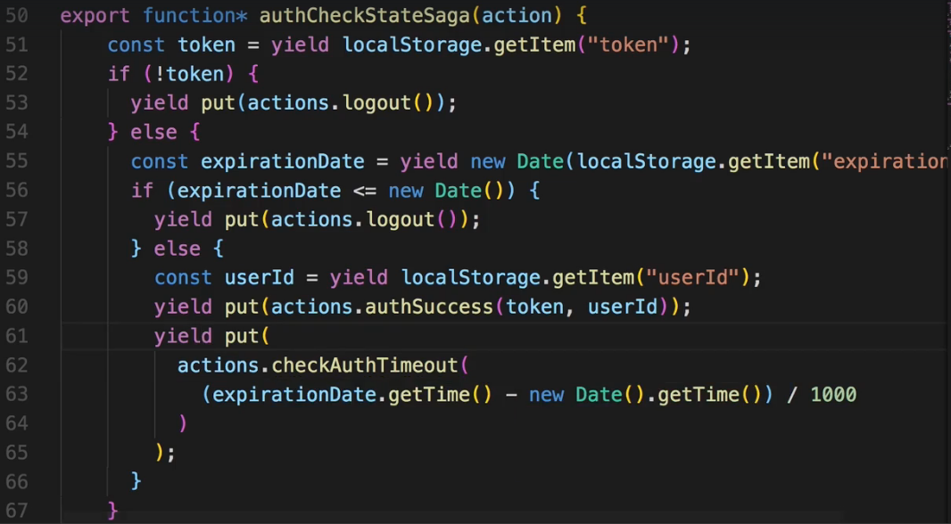  
* Again let’s create a new ACTION TYPE for this and use it in ACTION CREATOR auth.js file.  
  
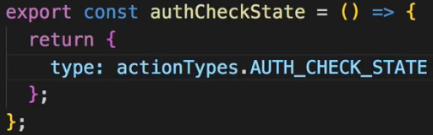  
* In `sagas` index.js:  
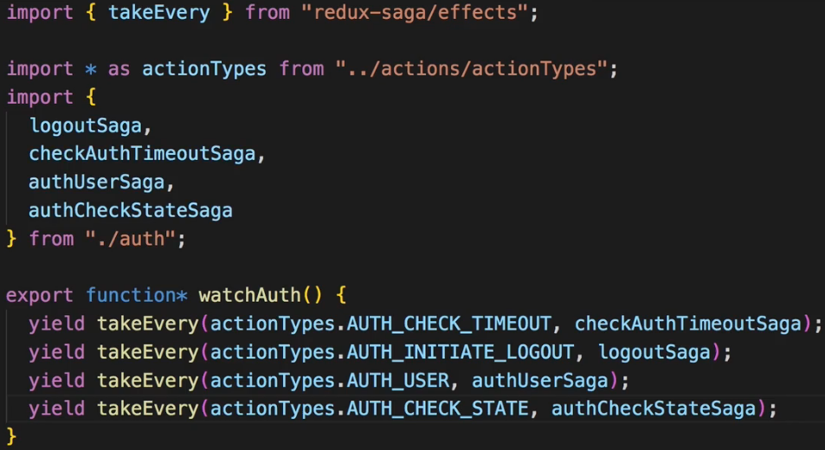  
* Now the auth.js ACTION CREATOR file is done.  
**Moving the BurgerBuilder Side Effects into a Saga**  
* In burgerBuilder.js ACTION CREATOR file we already got a lot of pure ACTION CREATORs.  
* But we have 1 which runs some Asynchronous code:  
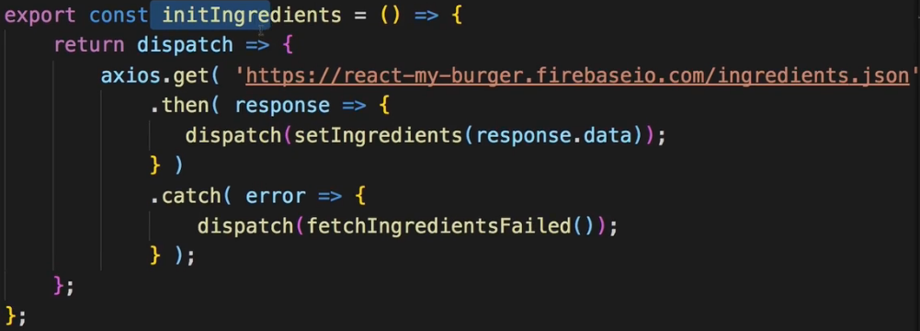  
* Creating burgerBuilder.js in `sagas`.  
* NOTE: The axios we use right here comes from our own axios instance.  
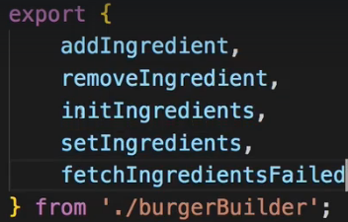  
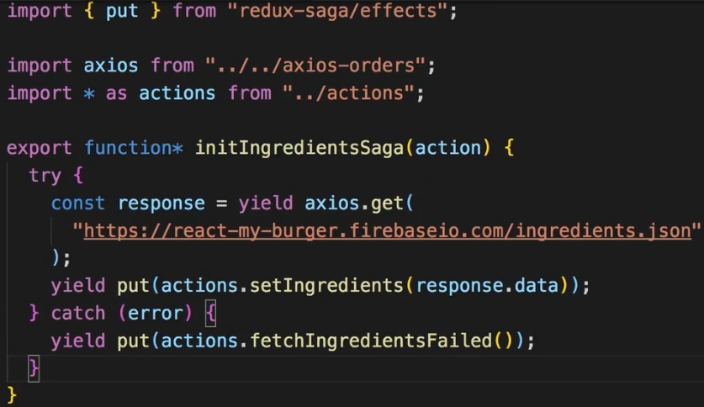  
* Now to register it we could have 1 big watch generator but I like to have multiple ones.  
* And now I need a new ACTION TYPE which we actually dispatch in the burgerBuilder file in the `actions` folder.  
* In actionTypes.js:  
  
* In burgerBuilder.js `actions`:  
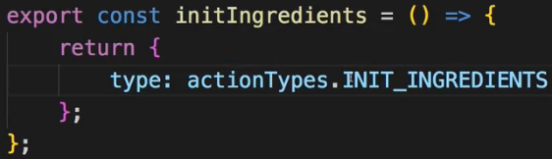  
* In index.js `sagas`:  
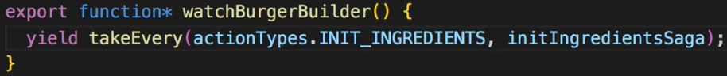  
* In main index.js:  
  
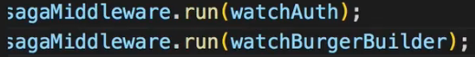  
**Moving the Orders Side Effects into Sagas**  
* In order.js ACTION CREATOR file:  
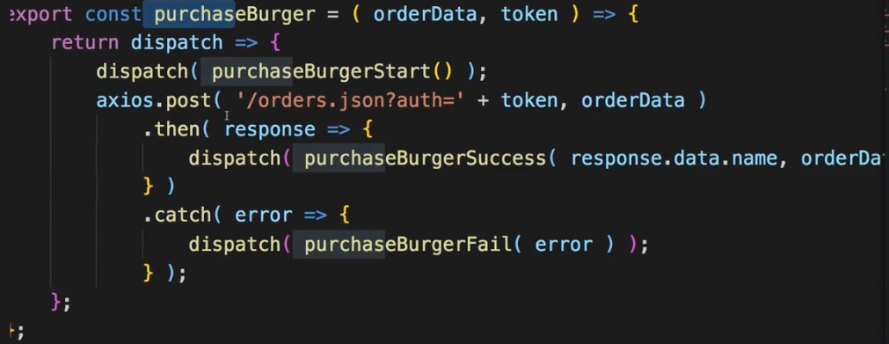   
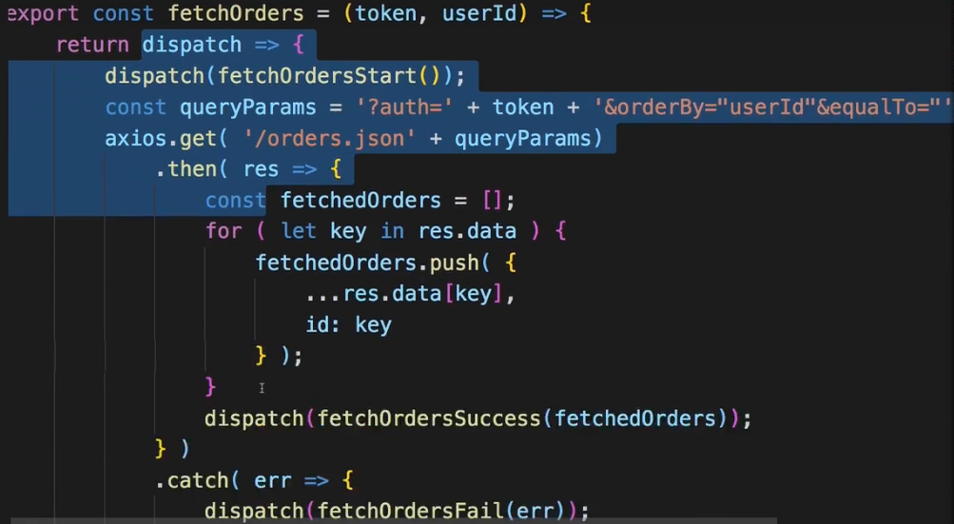  
* Let’s start with purchaseBurger.  
* Creating order.js in `sagas`.  
* Here we’re also using that custom axios instance.  
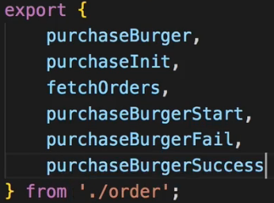  
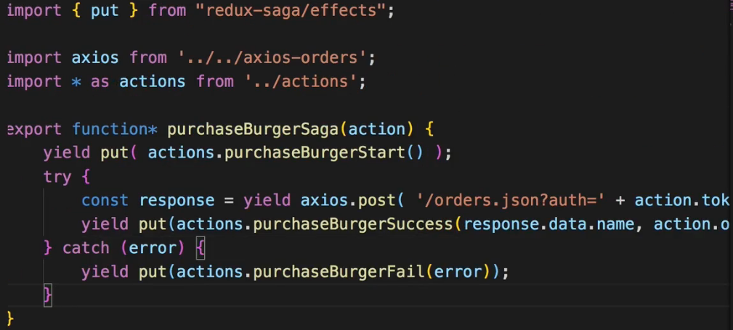  
  
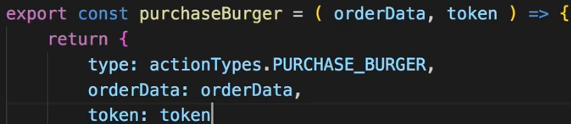  
=> We pass on these so that we never have to change any code anywhere in our application because the ACTION CREATOR works as before - it just now only creates an ACTION instead of running some code. That’ll be done in the saga.  
  
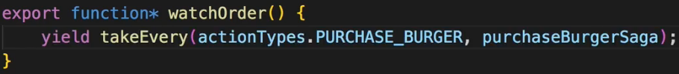  
  
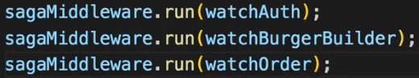  
* Now it still works. We can make a successful purchase.  
* Now let’s change the fetchOrders.  
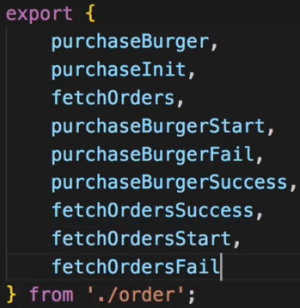  
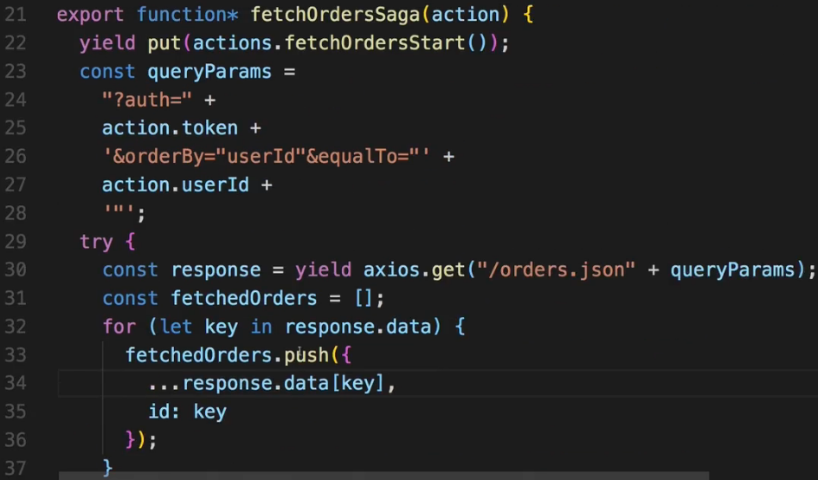  
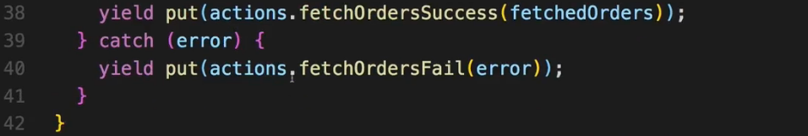  
  
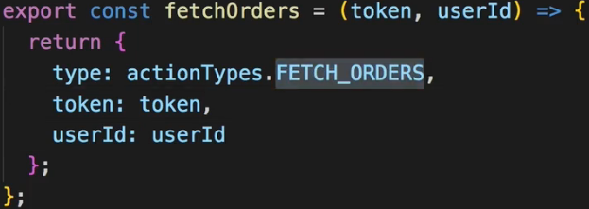  
  
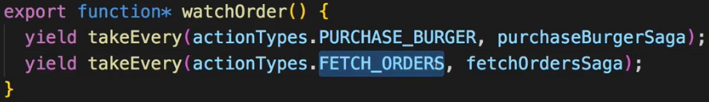  
* Now all of this still works, now through Redux Saga.  
**Why Sagas can be Helpful**  
* We moved the Asynchronous and also the Synchronous Side-Effect code from our ACTION CREATOR files to our sagas.  
=> The “advantage” in “” because it’s not necessarily better - it depends on what you prefer - so the “advantage” can be that our ACTION CREATORs are all very lean. They really do just 1 thing: they create an ACTION, they don’t run any other code. And all our Side-Effect code - so the code that is not related to REDUCERs or to ACTIONs, is in our sagas.  
=> This is where we have our API calls, our Local Storage calls, where we even might change the ROUTE we’re currently on.  
* This is a pattern you don’t have to use but it leads to leaner ACTION CREATORs.   
* Now there are a couple of other things I want to show you with Redux Saga which you also should be aware of and which should allow you to build really powerful applications.  
**Diving Deeper into Sagas**  
* Let’s start in the auth.js `sagas` file:  
=> Here we for example access localStorage:  
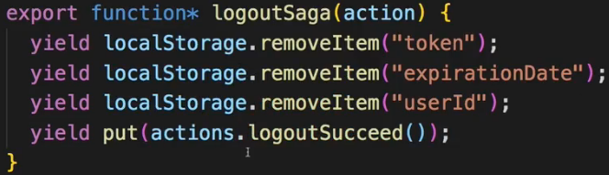  
=> And I used `yield` here even though technically this is a Synchronous code, we don’t need to wait for it.  
=> Now 1 thing you can do here is: you can use another HELPER METHOD/FUNCTION from Redux Saga.  
  
=> `**call**`. Call is a function which allows you to call some function on some object.  
=> As the 1st argument you pass an array where the 1st element is localStorage and as the 2nd element pass that function you want to execute on it.  
=> As the 2nd argument pass the arguments you’d pass to the `removeItem`.   
* Now you might wonder what the advantage of this is - after all, it’s longer than before.  
=> Well this actually makes your generators TESTABLE because you can easily mock this and not really execute this code while you always need to execute the previous code.  
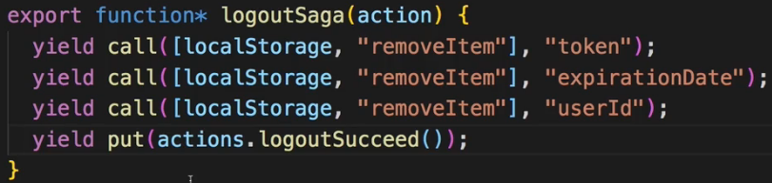  
* And you can use `call` wherever you use some object and call something, including axios of course or these localStorage calls.  
=> If you want to TEST generators, you should do it.  
* Now there’s 1 other thing you can do with it.  
=> In the index.js `sagas` file:  
=> Here we have all our `yield`s to set up our various sagas we want to execute on different ACTIONs.  
=> Here we can import `**all**`, another nice function.  
  
=> We can now all() and pass an array of all the ACTIONs we want to yield.  
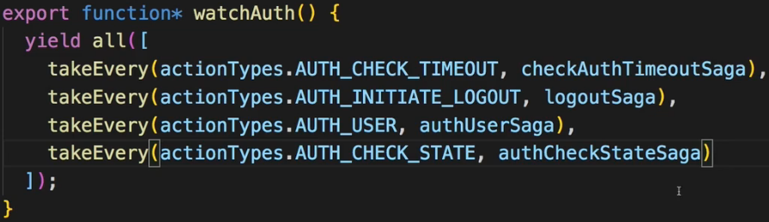  
* Now it’ll still work as before so all our auth related watchers are still working, but with all() they’re actually run concurrently. Now here this doesn’t matter at all because when we yielded them after each other, it didn’t pause anyways because it were Synchronous tasks.  
* But you can not only use it here when setting up the watchers, you can use it anywhere. For example where we have these 3 call()s here, you could execute them simultaneously with the all() by wrapping it, however, these also are Synchronous. BUT if you have for example 2 AXIOS Requests and you want to run them simultaneously, you can use all() to do just that.  
* So all() is another nice option if you want to run multiple generators or multiple tasks (don’t have to be generators) simultaneously. Again, you could use it for the other watchers too, it’s not really required here though.  
* 1 other thing I want to show: we always use `takeEvery` which can really be translated as this: Take every ACTION of this TYPE and execute this SAGA.  
=> Now in our application this behavior is alright, but what if you actually just wanted to have 1 of the sagas run at any time?  
=> So for example if the user hammers the “Purchase Burger” button, we maybe always want to use only the latest click. That is why besides `takeEvery`, we can also use: `**takeLatest**`.  
  
=> takeLatest will automatically cancel any ongoing executions of purchaseBurgerSaga and always only execute the latest one.  
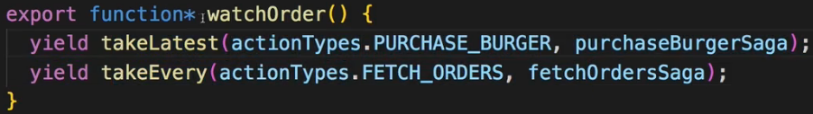  
* So that’s another nice addition which you might need from time to time to make sure that only 1 of these processes here is going on at a time.  
* With `takeEvery`, it’ll execute fetchOrdersSaga whenever this FETCH_ORDERS ACTION TYPE is detected.  
* And there is more - you can check the official page <https://redux-saga.js.org/docs/api> and there you can find an API Reference with all the functions it exposes. Now this looks like a lot but you probably don’t ever need most of them.  
* You can also dive there into some Advanced Concepts on this documentation or go through the Basic Concepts again in case something is unclear.  
* In its core the whole idea behind Redux Saga really is to make sure your ACTION CREAsTORs are lean, that you don’t run any Side-Effects in there, but that you instead handle these Side-Effects in your sagas, that you have 1 place where you have all the Side-Effects and 1 place where you have all the ACTIONs, and that you don’t mix that.  
**Redux Saga: Full Documentation** => <https://redux-saga.js.org/>   
**Advanced Concepts**: <https://redux-saga.js.org/docs/advanced/>   
**API Reference**: <https://redux-saga.js.org/docs/api/>   
**Pros & Cons for Redux Saga vs Thunks**: <https://stackoverflow.com/questions/34930735/pros-cons-of-using-redux-saga-with-es6-generators-vs-redux-thunk-with-es2017-asy/34933395>